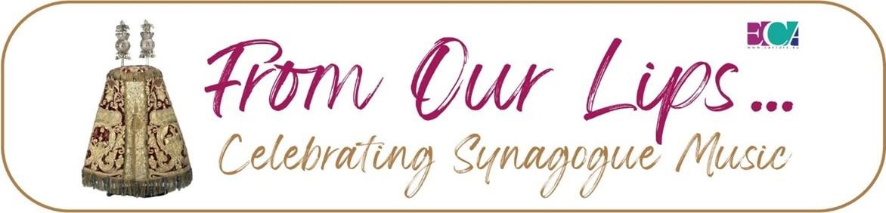

**An inspiring festival** generated by the European Cantors Association

**Celebrating the Music of Jewish Prayer** in 15 synagogue services, January to April 2024 **Report by Geraldine Auerbach MBE**

**These were my ten takeaway impressions from the wonderful services presented this year.**

1. Each participating synagogue took great pride in the music they presented, taking special care in discussing music with the relevant people. The prayer leader, the honorary officers, the rabbi and community members played a part in deciding what to deliver and who should deliver it.
2. All participating synagogues made sure their congregants knew that there would be a musical service and which composition or traditional tunes they would be singing for which prayers.
3. It was surprising how similar the repertoire was in all strands of Jewish worship. The music in Orthodox, Masorti, Independent and Reform synagogues all embraced the big-name 19th century liturgical composers of Lewandowsky (Berlin), Sulzer (Vienna) Mombach (London). The influence of the ubiquitous ‘Blue Book’ a compendium of choral and cantorial music from 1899, was still paramount in all strands, creating a strong sense of belonging and satisfaction.
4. There was also some popular innovation in each synagogue service with particular favourites of more modern music (some composed in-house by their resident choirmasters or composers) that are also enjoyed by the communities.
5. It was striking how a good strong and confident voice from the *bimah* galvanised the congregation and created a real buzz in the synagogue.
6. A sensitive choir and choirmaster lea the congregation in song creating a rich atmosphere.
7. I was surprised at how attentive the congregation of Mill Hill United Synagogue was – and then realised that they had all been asked to request what their guest cantor and resident choir would sing. There had been many suggestions. They were sitting on the edge of their seats hoping that their choice had made the cut!
8. What was a revelation to congregants, was that often for the very first time, synagogue managements and prayer leaders told their members which tunes were being sung, either in emails in advance, or with a helpful handout for each congregant on the day, or actually telling them from the *bimah* who composed the music for a particular prayer and when. They had been ignorant before that, and they found this information engaging.
9. Often the prayer leader was invited to the *bimah* to talk about music and the Rabbi also engaged with the music of Jewish prayer in his sermon, informing the congregation about the music they were singing.
10. I was most surprised that many synagogues seem to think that this is an annual event and are already planning what they will do next year for music in their synagogue, to build on this years’ experience.

**So, watch this space** as we have announced new festival Celebrating Synagogue Music for January to April 2025!! We hope many more synagogues around the country will participate next time.

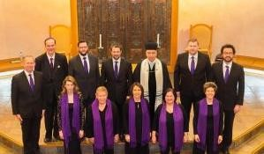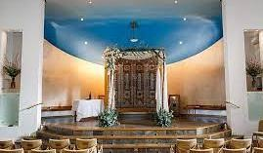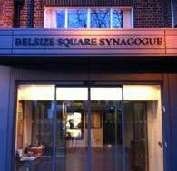

# Reports on each of the festival services

**Belsize Square Synagogue – London**

51 Belsize Square, London NW3 4HX

Festival Services: 19, 26 and 27 January 2024 **The German *Liberale* Tradition**

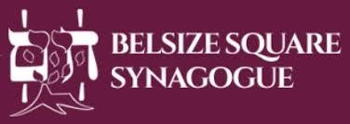Belsize Square Synagogue, in Swiss Cottage, is an independent synagogue, founded in 1939 by refugees mainly from Berlin, Frankfurt and

Vienna, with help from Lily Montagu of the Liberal Movement in Britain. This congregation preserves the nineteenth-century German *Liberale* Tradition in liturgy and music. Prayers are mainly in Hebrew. They have their own *siddur* (prayer book) and holiday prayer books prepared by Rabbi Rodney Mariner in the late 20th century. Current membership is around 1200 and about 80 attend on Shabbat. Services are also live-streamed and as many again may join online.

## The Belsize music tradition

**Their music**, led by the cantor accompanied by choir and organ is heavily based on the Western harmonies of music by Louis Lewandowski (1821-1894, active in Berlin) with some music by Salomon Sulzer (1804-1890, active in Vienna) and a few others. The actual music scores first used at Belsize Square, were rescued by their first cantor from the ashes of the [*Fasanenstrasse* Synagogue](https://www.google.com/search?client=firefox-b-d&sca_esv=597534592&sxsrf=ACQVn0-jQmf0qf0E1pU6yQd-cOQzTNrRMQ:1704984959770&q=Fassanenburger+Strasse+synagogue&spell=1&sa=X&ved=2ahUKEwi1iP_2y9WDAxWsYEEAHWzBBUYQBSgAegQIDhAC) in Berlin after ‘Kristallnacht’.

Belsize employs a full-time professional cantor (Paul Heller). They employ a professional choir, that sings every Friday night and also for the High Holydays and other festivals. Their community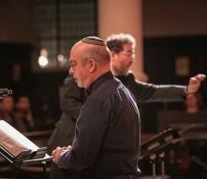choir sings on certain shabbat mornings. Both choirs are conducted by their Music Director, [Benjamin Wolf](https://www.synagogue.org.uk/services/our-music/benjamin-wolf/) and are gently supported and accompanied by [Michael Cayton - Organist.](https://www.synagogue.org.uk/services/our-music/michael-cayton/) Their distinguished previous cantors, Revs: Magnus Davidsohn, Joseph Dollinger, Louis Berkman, Lawrence Fine and Norman Cohen Falah, (who added a Sephardi element) developed and shaped their musical offering, that is especially enjoyed by congregants and visitors. Ben Wolf also introduces music by contemporary composers including some of his own compositions.

Pictured are Cantor Paul Heller, at the front, and Ben Wolf conducting behind

Belsize Square Synagogue also has a regular **youth choir**.

[**Paul Heller**](https://www.synagogue.org.uk/belsize/cantor-heller/) has been the cantor **Since 2013**. Paul, who is now the only full-time cantor in

London, has the title of ‘Cantor and Minister of Religion’ and his role encompasses all liturgical, pastoral and educational duties, including standing in for the rabbi in his absence.

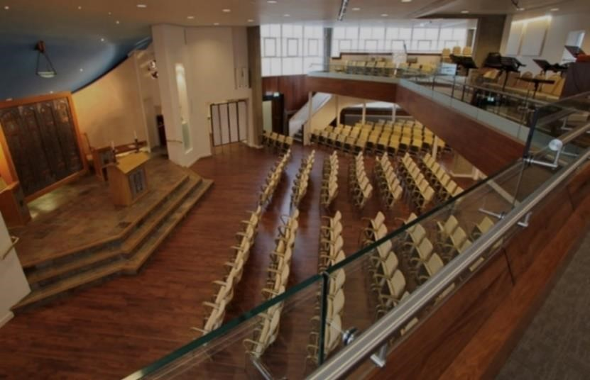**The layout of the synagogue:**

Completely remodelled in the 1990s the synagogue space is flexible with moveable upholstered chairs arranged around a ‘platform’ or ‘stage’ where the Aron Kodesh and rabbi’s and cantor’s chairs are set against the back semi-circular wall. As you can see in the pictures, the professional choir members are standing (for the photograph) on the steps of the

platform, and behind them, with the candles, is the readers desk and behind that the Aron Kodesh.

The cantor, leading the service, stands facing the Aron Kodesh, with his back to the congregation. The rabbi and the readers, stand with their backs to the Aron Kodesh and face the congregation. Men and women sit together wherever they please in the gallery or downstairs.

## The ‘From Our Lips …’ Festival Services

**Belsize Square Synagogue** chose Shabbat Shirah – the shabbat of song – to honour their three choirs. In the Friday night service on 26 January (6.45-8.15) music director Benjamin Wolf was invited to the *bimah* to speak to the congregation about the weekend’s musical programme. He mentioned Henry Kuttner and also Sue Mariner who had done so much for music at the synagogue in their day. He spoke about the meaning of music in the services and described to the congregation, what compositions they would be singing. He then went upstairs to conduct from the gallery that stretches across the back of the hall where the choir and organist are stationed. Theysang the following to a satisfied and decorous congregation of 49, some of whom were guests of the family of a forthcoming barmitzvah.

*Lecha Dodi –* Mombach

*V’shamru* – Dunajewski

*Hashkivenu* – by their own previous Youth Music Director, Sue Mariner

*Yigdal – Saqui* as well as other Lewandowski melodies

# Shabbat Morning at Belsize

**On Shabbat morning** at Belsize, (10.00am – 12.30) Cantor Heller officiated this time with the

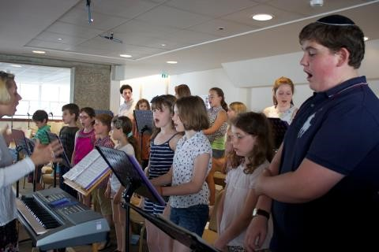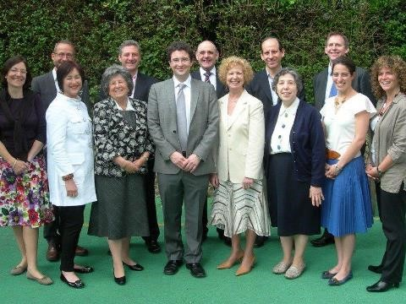

**Community Choir,** also conducted by Ben Wolf with Mike Cayton on the organ. This is a group of 16 to 20 men and women, which participates on Shabbat once a month and on special occasions. b

This week they also celebrated their **Youth Choir** which was established in the 1950s to make the children feel at home with their synagogue music. The Youth Choir is now conducted by Sofia Swenson-Wright. They rehearse during cheder and sing the whole *Mincha* service on Yom Kippur as well as at all bar- and batmitzvah services. They also give performances throughout the year in the synagogue and at care homes.

Recently appointed **Rabbi Gabriel Botnick** used the occasion, to emphasize the inclusive and multi-generational nature of the synagogue’s musical tradition.

**The service on Sat 27 January included:**

*Barechu* – Lewandowski

*Mi Khamocha* – Lewandowski

*Avinu Shebashamayim –* Sol Zim (Youth Choir) *Kedusha*:

*V’shamru* – Lewandowski

*Ki Lekach Tov* – Youth Choir to a favourite tune, composer unknown

*L'Dor Vador* – Finkelstein – all choirs together

*Ein Keloheinu ?*

*Adon Olam* - Uzi Hitman (All choirs)

The Previous week on Friday 19 January, **Yohel Heller**, Paul Heller’s sonwas the guest cantor at

Belsize. He opened with **Sulzer’s *Ma Tovu*** and ***Lecha Dodi,*** Birnbaum’s ***Hashkiveinu***, Putterman’s ***Ushmor***among other of the regular Lewandowski repertoire. Cantor Paul Heller delivered the sermon, emphasizing the community’s strong musical commitment and identity after the darkness of the Shoah, further highlighting the rich musical heritage of Belsize Square Synagogue

Belsize Square Synagogue has several pages on their website about their music and musicians.

Read more here [About Benjamin Wolf](https://synagogue.org.uk/services/our-music/benjamin-wolf/) and [Cantor Paul Heller - Chazan](https://www.synagogue.org.uk/about-us/cantor-heller/)  and [Michael Cayton - Organist](https://www.synagogue.org.uk/services/our-music/michael-cayton/) Read more about their music here [Music at Belsize.](https://synagogue.org.uk/services/our-music/professional-choir/) [The Belsize Square Synagogue YouTube channel](https://www.youtube.com/channel/UCWRrZFRT2G-xlqUHeWLgfDw) features highlights of Belsize music.

~~~~~~~~~~~~~~~~~~~~~~~~~~~~~~~~~~~~~~~~~~~~~~~~~~~~~~~~~~~~~~~~~~~~~~~~~~

# Central Synagogue – London

36 Hallam Street,

W1W 6NW

Festival Services: 27 January and 16 March 2024

Central Synagogue was established in 1855 as a ‘central’ branch of the

Great Synagogue, Dukes Place in the East End, following the migration of Jews westward in those times. In 1870 it became independent with a

dedicated building in Great Portland Street. That first Central Synagogue building was destroyed by bombing in 1941, the current synagogue on the same site (between Great Portland and

Hallam Streets) was consecrated in 1958. It is an orthodox synagogue, a constituent of the United Synagogue. Its current membership is approximately 600. Central has hosted many cantorial concerts and also three European Cantors Association, Conventions since 2012.

## Cantors at Central

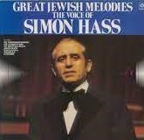From 1951 to 1993 **Rev Simon Hass** was the revered cantor at Central Synagogue. Born in Poland in 1925, Hass was widely admired and respected as one of the finest cantors in the world, gifted with vocal brilliance combined with humility, prayerful majesty and devotional intensity. It was Hass who introduced the first **midnight selichot service** in London in 1963. He made countless concert, radio and TV appearances and produced many outstanding recordings of a wide repertoire. When he passed away in December 2022, aged 97, the Jewish Chronicle said he was an ‘Exceptionally gifted, musically sensitive and majestic cantor whose passing risks the demise of inspirational chazanut’

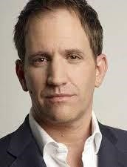Currently, since 2003, Central employs and enjoys **Steven Leas** as their part time cantor. Steven, from South Africa, who originally came to join the Royal Opera House operatic school, involves himself with every member of the community and is a much-loved participant of the synagogue clergy. Steven drives the music and chooses the repertoire. He knows well what the members expect and enjoy, but because he has such a close relationship with them, he is able to surprise and delight them with new melodies and sometimes even some cheeky tunes. They expect about 100 attendees on a regular Shabbat. There were only a handful of young children at the service that I attended. I don’t know if children’s services took place in other spaces.

At their *Shabbat Shirah* Service On 27 January 2024, Central honoured two of their stalwart women in the community*.* As there was to be no sermon as such, Cantor Steven Leas, who has been the part-time Cantor at Central Synagogue for the last twenty years, was given the opportunity to talk about music. He has a very warm rapport with his community. For many years

Steven and his family lived ‘above the shop’, in a flat in the shul building. At one time he was also the synagogue ‘events manager’. He became part of the very fabric of the community and was always on hand. Steven now lives in Hampstead Garden Suburb and officiates at Central three weeks out of four.

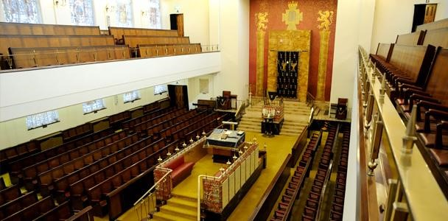

## Layout of the synagogue

As you can see in the picture above, Central Synagogue is a large imposing building. As is traditional in Orthodox synagogues, the *bimah* (reading desk) is midway down the synagogue and rows of seats face each other on either side. The ladies’ gallery wraps around the sides and back.

**The Central Synagogue Choir** of six men, conducted by **Harry Style**, participate at least once a month. Being in such a big space, the choir stuck closely by Steven. When he was on the *bimah* the choir was close around him. When Steven went up near the Aron Kodesh, (the Holy Ark) the choir followed him and stood on the steps, making the most impact on the congregation of almost 50 men spread-out downstairs and 55 women upstairs. (Perhaps this was an exceptional number of women because two of their long-time women members were being specially honoured).

Steven and the choir sang *Mishebeirach* for Israel by Sol Zim. The *Kvodo* was sung to ‘Bring Him

Home’ from *Les Miserables*. The congregation was riveted by the counter-tenor choir member

Eliran Kedussi, singing Talmon’s version of *Ein Keloheinu*. Steven keeps his community on their toes with a surprise up his sleeve each week for Adon Olam.

At the end of the service – all the women upstairs were invited to come down and join the menfolk, sitting anywhere they chose, for the praising of the ‘Women of Valour’ in their community. (They do this too for girls celebrating Bat Mitzvot where they are invited to come down and address the congregation with their *Dvar Torah.*) Rabbi Lehrer spoke about the pair’s commitment to the synagogue and each of the women, who were seated in the presidential box in front of the *bimah*, were invited up to a special lectern set up for them. They each spoke about their devotion to Central Synagogue.

Steven and choir presented a similar service on 16 March. There is no section for music on the Central Synagogue website but you can read about [Cantor Steven Leas](https://www.centralsynagogue.org.uk/about-us/chazan-steven-leas/) in the ‘About’ section.

Central Synagogue, 36 Hallam Street, W1W 6NW website: <https://www.centralsynagogue.org.uk/>

~~~~~~~~~~~~~~~~~~~~~~~~~~~~~~~~~~~~~~~~~~~~~~~~~~~~~~~~~~~~~~~~~~~~~~~~~~

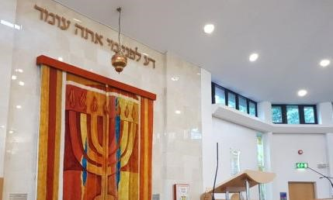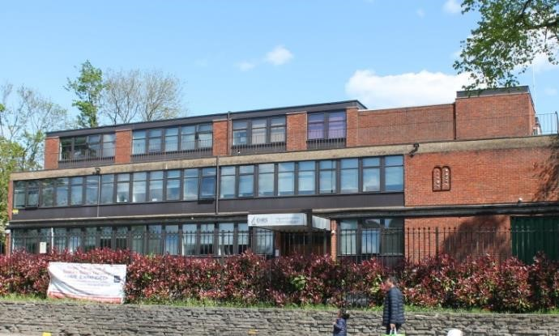

**Edgware & Hendon Reform Synagogue**

Festival Services 3 February 2024

EHRS, 118 Stonegrove Edgware, HA8 8AB *Tel:* 020 8238 1010Web: [www.ehrs.uk](http://www.ehrs.uk/)

The Edgware and District (est.1935) and the Hendon Reform Synagogue (est.1955) both flourishing reform communities, merged in 2017 to become the Edgware and Hendon Reform Synagogue (EHRS) occupying the site in Edgware. It is a large and diverse community with a membership of nearly 2000 families.

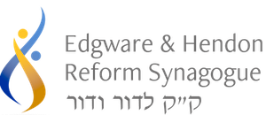EHRS Rabbis, Mark Goldsmith, Debbie Young-Somers, and Tanya Sakhnovich are all actively involved in and passionate about the musical and prayer life of the community and have developed innovative and inspirational services to cater to the diverse prayer needs of the community.

Music was very much in evidence on the Shabbat that I visited on 3 February. There is always the‘Classic’ Service every week in the spacious and bright sanctuary which is double height with clerestory windows and has a strikingly bright embroidered ark covering. The business end is all at the front – but the seats on either side face inwards and there are also rows in the middle, facing the front.

## The Classic Service

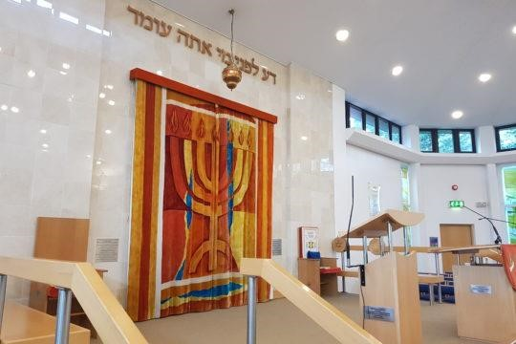

There were upwards of 200 people at the classic service that day, which is usual for a Shabbat at EHRS. The service does not differ greatly musically from an orthodox one, except maybe that on the whole people don’t walk around so much and due attention paid to the prayers – and of course the fact that men and women sit together. This service in Hebrew and English was led by Rabbi Debbie Young-Somers. Along one side, sat the mixed choir, who sing *a capella*, conducted by Simon Masterson-Smith. They play a prominent role in the service alongside a cantorial soloist, who on the day I attended, was **Sara Feldman Brummer** (who also officiates in some weeks in this role at Westminster Synagogue – which was part of the festival on 13 April). Sara has kindly sent me a full list of all the music they used during the Classic Service for the soloist and the choir as well as the community – when they all sang together. I attach this list at the bottom of this review. You can see that this is mainly very familiar Anglo-Jewish orthodox material, much of which can be found in the ubiquitous ‘Blue Book’ compiled in 1899 by DM Davis and revised in 1933 by Samuel Alman, choirmaster (with a mixed choir) first at the Great Synagogue, Dukes Place then at Hampstead Synagogue.

The ‘Classic Service’ is live-streamed, so many people also participate from home. They have the option of half the screen showing the *siddur*, which is their new Daily and Sabbath Prayerbook, ***Seder Ha-T’fillot, Forms of Prayer***, published in May 2008, after much deliberation as to gender inclusiveness and other considerations. Besides containing all you would expect, this new prayer book also deals with contemporary issues, such as social justice and the environment, which are addressed in specially commissioned prayers and there is also new material offering more musical opportunities to enhance services.

### The HaKol B’Seder Musical Service

In addition to the Classic Service, EHRS holds a more intimate and interactive service that they call **HaKol B’Seder** – meaning**,** ‘anything goes’. This is the one that I attended.This varies from week to week. The services both started at about 10.30 and ended at 12.30 followed by a kiddush together. I did not notice any children in the synagogue – but as there are many children in the cheder, I assumed they might be at a service somewhere else in the large building.

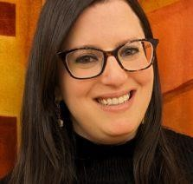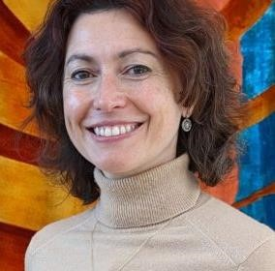The ‘From Our Lips …’ Festival

Celebrating Synagogue Music ‘Anything Goes’ service was held in the synagogue lounge, around a conference table. It was run by **Rabbi Tanya Sakhnovich** (right) with newly appointed **Cantor Tamara Wolfson** (left). We used notes on paper and on screen rather than a prayer book.

Everyone, of the 15 people present, and the three or four who joined us on Zoom, was encouraged to participate by reading part of the service and in the discussion about the music of prayer.

The service was framed by the quotation from Rabbi Kook **‘Making the Old New – and Making the New Holy’**. This was a very fitting title for those involved with the music of Jewish prayer as this is the age-old conundrum of what music is acceptable and enjoyable to communities and why?

Cantor Tamara who joined EHRS as Cantor at the beginning of 2024 introduced each piece (as listed below) that she sang and told everyone who the composer was and where he or she came from and when the piece was written. This was a revelation to everyone who expressed much appreciation saying that up to that time they had no idea about the provenance of the pieces even if they were very familiar with them. Nobody had told them who composed them or when, before. (I have always felt that congregations would pay more attention to the music they hear in shul if the cantor – or somebody – would tell them what they were going to sing/hear. However, it seems that orthodox cantors are inhibited by their systems – or just not allowed – to talk to their congregations, which to me is a pity).

This is the list of pieces that Cantor Tamara presented to the group for the service.

***Mah Tovu*** – Louis Lewandowski (1821-1894)

Morning blessings – Shabbat nusach

**Psalm 121 *(Essa Einai)***– Charles Garland Verrinder (1839-1894)

***Shochein Ad*** – nusach

***Yishtabach***– nusach

***Bar’chu***– Louis Lewandowski (1821-1894)

***Shema*** – Salomon Sulzer (1804-1890)

***Mi Chamocha*** – Rabbi Hanna Tiferet Siegel

***Tzur Yisrael***– Israel Alter (1901-1979)

***Adonai S’fatai***– folk (unattributed)

***V’shamru***– Rabbi Moshe Rothblum (composed in 1970)

***Oseh Shalom***– Nurit Hirsch (composed in 1969)

***Ki Mitzion / Baruch Shenatan*** – Natan Shachar (1937-2021)

***Eits Chayim Hi***– Rabbi Tanchum Portnoy (composed in 1975)

***Aleinu***– traditional (unattributed)

***V’ne’emar / Bayom Ha’hu***– Traditional arr. Hayim Wasserzug (1822-1882)

***Adon Olam***– Uzi Hitman (1952-2004)

As you can see from the list above many of the pieces such as the Lewandowski (written for the reform movement in Berlin) Sulzer (written for mixed choirs in Vienna), Israel Alter for orthodox synagogue (Hannover) Wasserzug orthodox (Poland/Lithuania and London) and Verrinder, Reform, London, are all very familiar to Anglo-Jewish communities of all stripes. Verrinder, an

Anglican, was organist of the West London Synagogue for its first 45 years. He brought an Anglican musical background to synagogue repertoire, arranging Jewish melodies for choir and organ, and forging a novel Anglo-Jewish musical identity. Participants who had come to EHRS from an orthodox background felt very much at home with this music which is regularly used in orthodox services.

The shortened passages from the sedra of the week, were chanted by Tamara first in the AngloJewish tradition – and then in the American trop, and we discussed the difference. There was discussion on the pieces that were new and unfamiliar to the group and how they reacted to them.

I asked Cantor Tamara and Rabbi Tanya for their own comments on that morning’s activity. **Cantor Tamara said**: ‘I'm always struck by how often we pray, but how infrequently we speak about our personal relationships to prayer. As a Cantor, I am particularly interested in the music of our liturgy because of how deeply it connects to our sense of tradition, memory, and meaning. You can learn a lot about a person when you ask about the music they love. My goal at this **HaKol Beseder service** was to get to know the EHRS community through the lens of liturgical music, and by understanding each person's individual traditions. Through our singing of and discussions of the Shabbat morning liturgy, we unearthed new insights about one another and about some of the values that underpin prayer at EHRS.

There is a strong sense here that the community value their musical traditions. At the same time, people are hungry for change, and to learn and sing new things. We spoke about the tensions between the comfort and familiarity of tradition, and the excitement and modern relevance of musical innovation. This is a deeply thoughtful and caring community, and it was wonderful to sing and pray with them in this way, in parallel to the classic service occurring in the sanctuary.

**This is the list of the music used in the EHRS Classic Service on 3 February.**

|  |  |  |
| --- | --- | --- |
| **EHRS Classic Service – Music List 3.2.2024**  Choir conducted by Simon Masterston-Smith Cantorial Soloist: Sara Feldmann Brummer | | |
| **Title** | **Composer** | **Choir or Cantorial Soloist** |
| Mah Tovu | Danny Maseng | Choir |
| Elohai n’shamah | *Shabbat Pesukei D'Zimra nusach* | Cantorial Soloist |
| Morning Blessings | *Shabbat Pesukei D'Zimra nusach* | All |
| Baruch she’amar | *Shabbat Pesukei D'Zimra nusach* | Cantorial Soloist |
| Hall’lu (Psalm 150) | Joseph Finlay | Choir |
| Nishmat | Joel Sussman | Choir |
| Shochein ad | *Shacharit nusach* | Cantorial Soloist |
| Yishtabach | *Shacharit nusach* | Cantorial Soloist |
| Chatsi Kaddish | *Shacharit nusach* | Cantorial Soloist & Choir |
| Bar’chu | *Shacharit nusach* | Cantorial Soloist |
| Yotseir or | *Shacharit nusach* | Cantorial Soloist |
| Ahava rabah | *Shacharit nusach* | Cantorial Soloist |
| Ha’eir eineinu | Carlebach | Choir |
| L’ma-an lo neivosh | *Shacharit nusach* | Cantorial Soloist |
| L’ma-an tizk’ru | *Shacharit nusach* | All |
| Mi Chamocha | Lewandowski | Choir |
| Adonai Yimloch | Lewandowski | Choir |
| Tsur Yisrael | Ivor Warren | Choir |
| Amidah | *Shacharit nusach* | All |
| M’chalkeil | *Max Wohlberg* | All |
| K’dusha | *Shacharit nusach* | Choir |
| L’dor vador | Trad. Arr Ann Sadan | Cantorial Soloist & Choir |
| V’shameru | Trad. Arr Paul Norcross-King | Choir |
| R’tseih na / kadsheinu | *Shacharit nusach* | Cantorial Soloist |
| V’tov beinecha | *Shacharit nusach* | Cantorial Soloist |
| Yiyehu Leratson | Traditional (old melody) | Choir |
| Oseh Shalom | Nurit Hirsch | All |
| Ein Kamocha | Sulzer | Cantorial Soloist & Choir |
| Vay’hi Binsoa | Unattributed | Cantorial Soloist & Choir |
| Shema and Echad | Lewandowski | Cantorial Soloist & Choir |
| Gad’lu l’Adonai | *Torah service nusach* | Cantorial Soloist |
| L’cha Adonai | Edward Hart | Choir |
| Eitz Chayim | Blumenthal | Choir |
| Hakol t’nu oz | Edward Hart | Choir |
| V’zot ha Torah | Edward Hart | Choir |
| V’zot ha Torah | Lewandowski | Choir |
| Y’chad’sheihu | Beethoven | Choir |
| Y’hallelu | *Torah service nusach* | Cantorial Soloist |
| Hodo al Erets | Mombach | Choir |
| Hovu | Mombach | Choir |
| Uv’nucho Yomar, Eitz Chayim and Hashiveinu | Lewandowski | Cantorial Soloist & Choir |
| Aleinu | *Musaf nusach* | All, led by Rabbi |
| Bayom Hahu | *Musaf nusach* | Cantorial Soloist & Choir |
| Anim Z’mirot | Traditional Chassidic tune | All, led by Ella Starkowitz (a child from the EHRS community) |
| Adon Olam | Traditional Ashkenazi melody, arranged by Paul Norcross-King | Cantorial Soloist & Choir |

~~~~~~~~~~~~~~~~~~~~~~~~~~~~~~~~~~~~~~~~~~~~~~~~~~~~~~~~~~~~~~~~~~~~~~

# Richmond Synagogue Services

Shabbat, 23 and 24 February 2024

Lichfield Gardens, Richmond, Surrey, TW9 1AP, <https://richmondsynagogue.org.uk/>

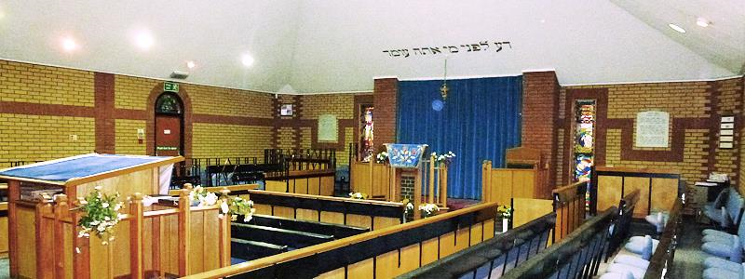

Richmond Synagogue, (a constituent of the United Synagogue) presented a weekend of services on 23/24 February for the Festival Celebrating Synagogue Music. As you can see, in the picture above, they have a

modern building, all on one level. It was opened in 1987, though a Jewish commmuity had been in the area since around 1900. (Read more of the fascinating [History](https://richmondsynagogue.org.uk/about-us/) of Jewish life in Richmond). It has the layout of an orthodox shul with a readers’ platform or *bimah* in the middle of the room

(left in the picture with seats on either side facing it and a few pews also in front of it facing the *Aron Kodesh* in the centre of the front wall (the Holy Ark where the Torah Scrolls are housed). For a service the pews furthest from us in the picture, are designated for women, who sit behind the ‘token’ metal screen. (The rows of pews are so close together that it is difficult to deal with your books and also to stand up and sit down, as required throughout the service.)

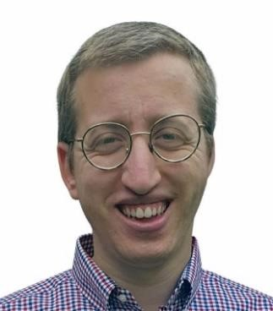The current community has about 200 members. Their new young Rabbi, Chaim Golker, a Behavioural Psychologist, appointed in 2022 (and previously head of the Cheder) is very keen on music. He and his wife Rebbetzin Gila Golker are warm and responsive to their flock. Richmond is an active community with several activities going on every week for adults and children. The service started at about ten o’clock with Rabbi Golker on the *bimah* holding his one-year-old baby in his arms, creating the warm and relaxed atmosphere in the shul for Shabbat. A few children were present at the service apart from the Rabbis children.

For the ECA’s ‘From Our Lips …’ initiative, the Richmond Jewish Community had invited a guest Cantor, **Rabbi Samuel de Beck Spitzer,** who was known from his Brighton days by Richmond members Alex and Tricia Brummer. They had advertised his presence widely amongst their community and friends and were pleased to see that attendance was at least twice the norm for a Shabbat in February. Of the 27 men present, it was estimated that at least 14 were not regular attenders and some of the 28 women present, told me that had come specially for the musical service.

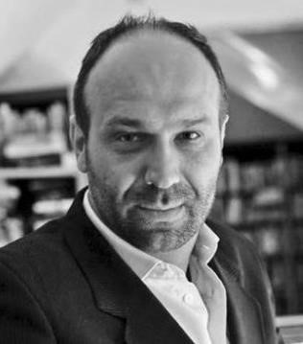**Rabbi Samuel de Beck Spitzer** has French and Indian-Iraqi Jewish heritage and grew up in both the Sephardic and Chasidic communities of Stamford Hill**.** As well as rabbinic studies in the UK and Israel, Rabbi Samuel studied music in London and Manchester gaining distinctions in piano and voice and has performed in operas.Before becoming rabbi of the Hove Hebrew Congregation in 2017, Rabbi Samuel led the Lisbon Jewish community. In 2023 he joined the RAF as a Jewish Chaplain.

He has a warm personality and was really pleased to have been invited and welcomed to Richmond so kindly for the whole weekend. He has a commanding presence and his rich baritone voice more than filled the small space. Though the members plus the Rabbi do well, singing every Shabbos, the difference was striking having a ‘real chazan’ for a change. People really paid attention. Though he might not even have sung as much as they usually do, his renderings of familiar melodies for *Mi Kamocha, Kedusha* and *Venucho Yomar* really hit home.

The chanting of the Torah portions according to the ancient, notated melodies, was expertly delivered by a regular, Hirsh Cashdan, and the Haftorah was chanted by another key member Alex Brummer. Invited to say a few words to the congregation, Rabbi Spitzer stressed how important music was for children and adults – going so far as to say that music should be compulsory at school – English, Maths and Music!

Richmond Chairman, **Paul Lawrence** is also very musical, and he harmonised with colleague **Jon Katzauer**, in support of guest chazan Rabbi Spitzer, both on the *bimah* and at the Ark **(**as they do regularly with Rabbi Golker)**.** After the service the community mingled at a sumptuous Kiddush, which included, besides the usual Jewish delicacies of herring and bridge rolls, some vegetable spring rolls and curry balls. They were pleased with the outcome and talked about what they might do next year – and indeed how in the meantime they might encourage post barmitzvah boys and other younger members of the community to sing parts of the services.

~~~~~~~~~~~~~~~~~~~~~~~~~~~~~~~~~~~~~~~~~~~~~~~~~~~~~~~~~~~~~~~~~~~~~~~~~~

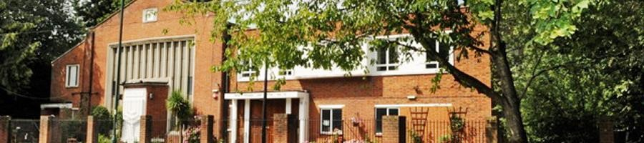

# Kenton United Synagogue – London

Shabbat 2 March 2024

Kenton United Synagogue, Shaftesbury Avenue, Kenton, Harrow, HA3 0RD

Affiliated to the [United Synagogue](https://www.jewishgen.org/jcr-uk/definitions.htm#united) from 1949, Kenton became a district synagogue in its present building in 1959. At its peak, during the 1970s and 80s, there were 1,200 families, with more than 600 children using its cheder and teenage centre.

The Kenton community, though much smaller today (370 members) and older with the changing demography, is nevertheless still dynamic. Rabbi Yehuda Black, who has been at Kenton for 20 years, and the committee, stimulate its keen members with religious, cultural and social activities for almost every day of the week, ranging from gardening to singing and dancing.

Many eminent rabbis and cantors have presided over the community, among them **Cyril Harris,** later Chief Rabbi of South Africa, who was also married in Kenton shul. In the 1970s **Eddie Jackson** was the Rabbi and **Geoffrey Shisler** the Cantor.

Kenton was the first of the US shuls to have batmitzvah ceremonies and their rabbis have always been very supportive of women in leadership roles. Kenton also led the way in adult education with weekly evening programmes with several classes running simultaneously.

## Two Guest Cantors –Geoffrey Shisler and Robert Brody – and a guest choir

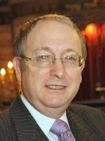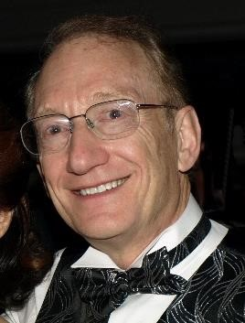Kenton invited a guest choir and two guest cantors for their ECA ‘From Our

Lips …’ service Celebrating

Synagogue Music on 2 March. In the 1970s Kenton had had its own excellent community choir, as there also had been at nearby synagogues in Belmont and Wembley. Belmont still has a choir. Wembley community has shrunk so much that they sold their synagogue building in 2022 and pray in a house nearby.

Kenton is most fortunate to have as a member, **Robert Brody**, the esteemed singer who has been a London favourite as a cantorial soloist at many synagogues as well as chief soloist for many Jewish choirs. Robert is regularly called upon the daven at Kenton, and I wonder if the community realises what a special gift they have. Robert is not only a superb interpreter of the prayers, but even after a long career as a soloist is in very fine mellifluous tenor voice. He is a true musician.

When Robert ascended the *bimah* to start the Shacharit Service, his voice soared into the space and brought everyone to a sense of connection with the text of the prayers. With the backing of the choir to harmonise and create volume, leading the congregation in song, brought back many happy memories of the days when Kenton shul was regularly full and had its own strong choir.

The community also welcomed back to Kenton **Geoffrey Shisler**, chazan, rabbi, teacher and magician**.** Geoffrey, who led the Musaf Service, had been the energetic and popular cantor at Kenton for 20 years in its heyday, from 1973 to 1993, He and his wife Anne are remembered with great fondness by the Kenton Community. They made a very considerable contribution to its development throughout its growth and prime years when there were 600 children in the cheder and had more than 1000 families as members. To hear his voice in the shul again was a real pleasure.

Geoffrey is also a dedicated teacher, passionate about nusach and the art of Jewish prayer

(which he taught at Jews College for many years). After serving Kenton, Geoffrey moved on to Bournemouth, as the Rabbi, and then ended his distinguished career from 2000 to 2014 as Rabbi of the New West End Synagogue, St Petersburgh Place.

Those Kenton children have now moved on to other places, leaving their parents behind at Kenton. There are still plenty of Simchas celebrated – but they are not bnei mitzvot or even weddings – but more likely to be golden wedding celebrations. In fact, the Kiddush on the occasion was held in honour of the 62nd wedding anniversary of members whom Geoffrey and Anne Shisler surely remember.

## The Layout of the Shul

Kenton shul has a very cleverly designed interior. Behind the Aron Kodesh (left in the pictures below) is a grid of beautiful stained-glass windows. Panning out (in the picture below right) we see pews on either side beyond the arches, making a compact shul area that can be screened

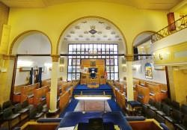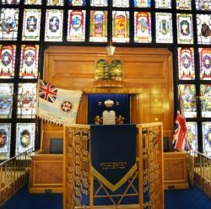

off, leaving a vast multi-purpose shul/hall with a gallery along one side and across the back.

On the day of the ‘From Our Lips …’ service, the spacious *bimah* (reading desk) was in place in the centre of the hall. Instead of banks of seats on either side, as you see in the picture, there were three rows of four white topped tables spaced out on each side, each table had one or two chairs behind it. When I arrived just after 9.30am, I was the only woman present. There were about twenty men downstairs – nine of whom were the guest choir who took up a position near the *bimah* on the right-hand side (looking at the picture) in two rows, each row behind two tables that were pushed together.

By the end of the torah reading part of service (it was an exceptionally long *Sedra –* portion of the Law) the numbers had risen to 45 men downstairs in the pews and at the tables and 35 women upstairs in the gallery in rows. It was said that this was slightly more than usual. The ‘tables’ arrangement proved to be very comfortable. As the prayerbooks (the Jonathan Sacks version of the Singers *siddur*) and *chumashim* (containing the text of the bible) have become ever larger and heavier, having a large flat surface to put them on, together with a tallis bag, a glass of water and any other paraphernalia was most convenient. The large space seemed comfortably occupied. The men were able to stand up and sit down at required times – and also to walk around with ease.

There was a warm atmosphere in the service. It was nice to see the warden (Leigh Lewis) with flowing white hair and beard and large tallis flouncing up and down between the tables with his card index, fixing the aliyot for the day. (They don’t have regular wardens but choose individual members to serve each week.) The *leyening* (reading from the Torah Scrolls) was excellently done by member, Stuart Leigh, and the Haftara read by another member, Cyril Brazil.

## The Guest Choir

The community had invited David Druce, who is the Chairman and past conductor of the London Cantorial Singers, and was also the Wembley Synagogue Choir Master, to source some singers specially for the ‘From Our Lips …’ Shabbat service. The group that he assembled was a wonderful combination of members of Kenton and Belmont synagogue as well as the Shabbaton Choir, the London Jewish Male Choir and the London Cantorial Singers. They were all steeped in the London orthodox repertoire and needed little rehearsal to provide a wonderful rich sound and ruach in the building, which has an excellent acoustics.

**What they sang:**

Between the Choir and Guest cantors we were treated to rich renderings in the Torah service of music by Sulzer and Lewandowski. ***Ana Avda*** and ***Eitz Chayim*** were composed by Geoffrey Shisler himself. Together with the choir and congregation they sang Sol Zim’s ***Avinu***

***Shebashamayim. Ashrei*** was a setting by Sulzer and Mendelssohn; ***Hodo al Eretz, Hovu*** by Mombach. For ***Ein Keloheinu****,* Geoffrey chose a well-known traditional tune that the congregation knew well and sang with great enthusiasm, as they also did for Stephen Glass’s arrangement of the ‘San Francisco’ tune for ***Adon Olam***.

## Impassioned speeches

Rabbi Yehuda Black gave a short but impassioned talk about his visit to New York last weekend to Chabad Headquarters at 770 Eastern Parkway, Brooklyn where 3000 children had gathered for a service and then all moved to Times Square, proclaiming their pride in being Jewish. And he was concerned at the world’s double standards not noticing the worst atrocity to Jews since the Holocaust on October 7 2023 – or the abuses of human rights in Syria, Somalia or China, but still accusing Jews of ‘genocide’.

At the end of the service Rabbi Geoffrey Shisler gave an equally impassioned speech about how the UK is losing its Jewish heritage in prayer music. He said there was a time 50 or 60 years ago when if a chazan put a note wrong for the time of day or Festival or Shabbat service – the Gabbai would correct him, and the congregation would be agitated by his lack of proper nusach. He bemoaned that fact that today the Gabbai would not notice, and neither would the congregation. Not even the Rabbi may be aware of what was in olden times, the correct nusach for the occasion – nor he thought, would they even care.

This does beg the question as to how important this is at the moment if it does not resonate with the clergy or congregation. There may be other considerations in prayer music that may have more pertinence for current congregations. Geoffrey also lamented that nowadays one often hears melodies from current musical theatre, or operas adapted to the prayers. He does recognise though that tunes by Handel and Mendelssohn have been accepted into the repertoire. It surely follows then that a community might legitimately feel drawn to the prayers sung to wellknown tunes by the world’s outstanding composers. Geoffrey certainly accepts that new tunes are permissible, as he himself has published two acclaimed books of music that he has written for Jewish prayer.

The purpose of the ‘From Our Lips …’ Celebrating Synagogue Music Festival is to find out what is moving congregations in prayer in the 2020s. Jewish communities are thriving, maybe not the same ones as years ago. ECA recognises that things move on le-dor-vador – from generation to generation and that the music that moves one generation in prayer may not be the same as previous ones. Another purpose of celebrating synagogue music is to encourage synagogues to think about what they are presenting to their communities in terms of quality and style of music for prayer. We are so happy to be celebrating so much variety (and also so much similarity) in the music of many different communities. And it is good to hear each synagogue thinking about where they are going next on this journey.

After the service– which the guest cantors were fearful was going on a bit too long, there was a generous Kiddush for all. Sadly they felt they had to leave out ***Yismechu*** which they had planned

to sing to a traditional melody arranged by Stephen Glass. The service ended at about 12.40.

Then, Robert and Linda Brody, who were hosting Geoffrey and Anne Shisler for the weekend, invited the choir members and their wives and also Ronnie and me, to their home for a delicious lunch accompanied by lusty zmirot and benching.

At the end of an eventful and enjoyable shabbat, Robert and Geoffrey recited Havdalah together.

Many thanks to all concerned for a

lovely musical and warm Shabbat.

~~~~~~~~~~~~~~~~~~~~~~~~~~~~~~~~~~~~~~~~~~~~~~~~~~~~~~~~~~~~~~~~~~~~~~~~~~

# South Hampstead Synagogue

3 Eton Road London NW3 4AY

Shabbat 2 March, 2024

South Hampstead, founded 100 years ago, was incredibly fortunate to be able to knock down a building and start again. In 2019 they more than doubled their space on the same footprint with a purpose-built community hub including a 400-seat synagogue, in Belsize Park. This was necessary as, since the arrival of Rabbi Shlomo and Rebbetzen Dr Lynndy Levin and their family, four decades ago, membership had risen from 200 to over 800 households. It is a warm, welcoming, vibrant, non-judgemental and religiously diverse community, open to new ideas and creativity.

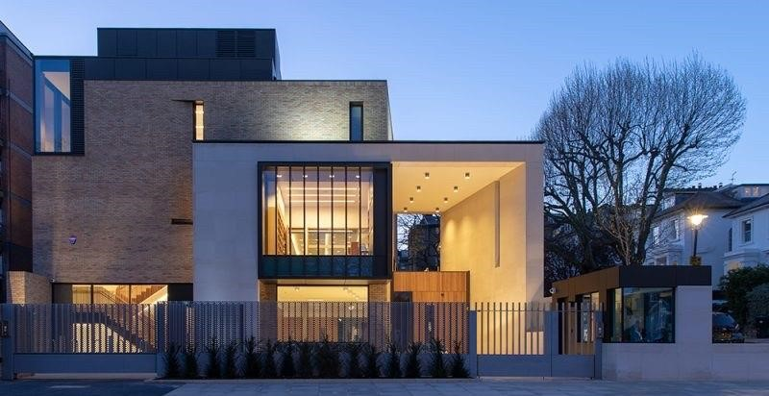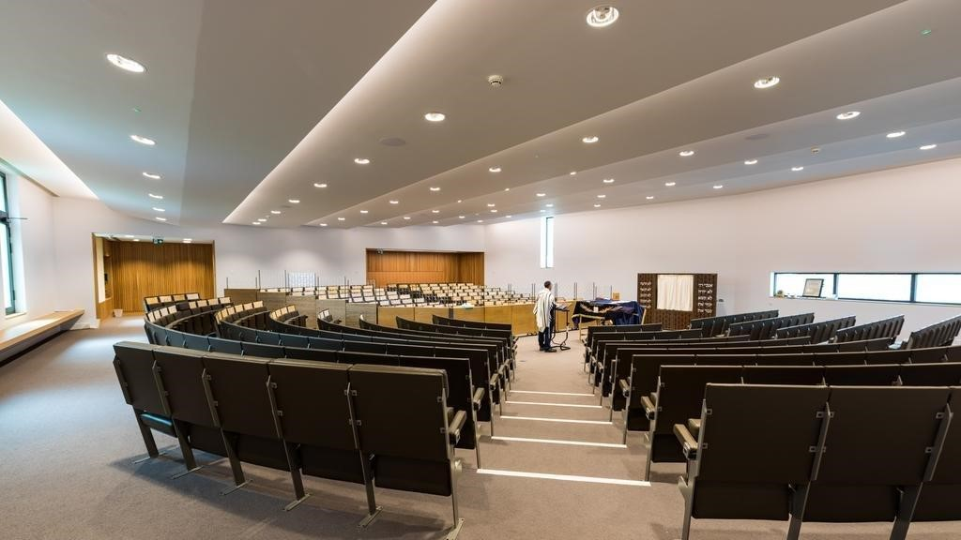

**Layout of the Synagogue**

The main synagogue is located on the first floor, while a variety of children and youth services take place in rooms on upper and lower floors. A smaller bet hamidrash on the ground floor is used for daily Mincha-Ma’ariv services and alternative services such as the occasional early shabbat Hashkama. Kiddushes and functions take place in the generous spaces of the basement hall and/or foyer.

The main synagogue is shaped as a raked amphitheatre, with seats for approximately two hundred men and a hundred women, enabling good views from the higher back rows on to the *bimah* which is a simple reading table on the lower central area in front of the ark. There is a modern, low fixed mechitza with a transparent movable upper section, enabling more-or-less full view and audibility for the whole community. Moreover, the upper section is lowered during sermons and announcements.

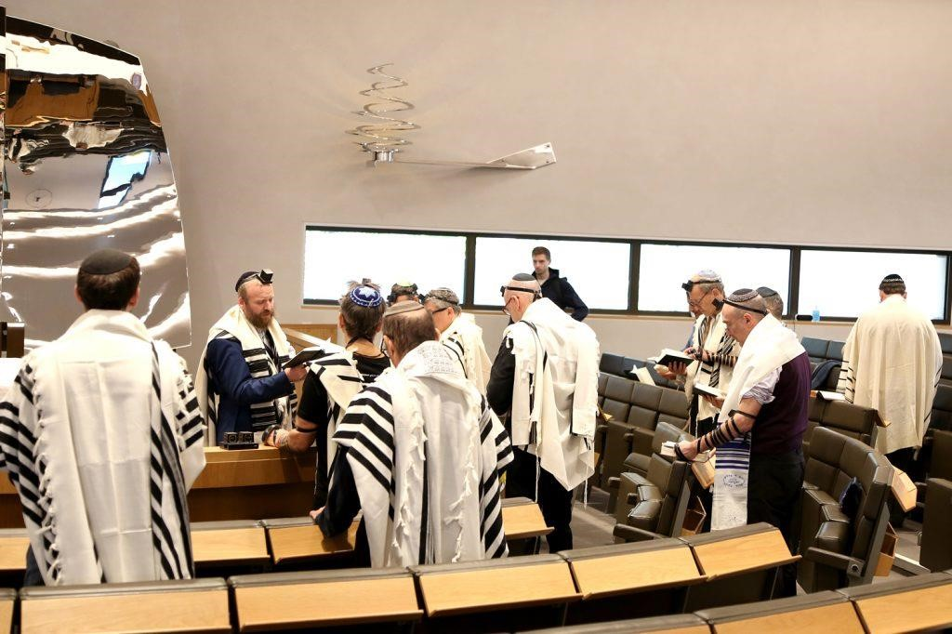

The commanding centrepiece is the large glistening ‘*Aron Hakodesh*’ (Holy Ark) complemented by a spiral shaped ‘*Ner Tamid*’ (everlasting light) a work of impressive contemporary art by Ron Arad, the acclaimed British-Israeli designer, a local resident. The asymmetrical gates of the Ark in beaten silver (which use a complex pulley system) suggest large wings, and produce reflections of abstract patterns that vary around the hall, evoking a spiritual symbolism. Aside from its functional and symbolic qualities, the piece represents a talking point for the community. From an acoustic perspective, it adds additional resonance to counter any dryness due to low ceilings and carpet.

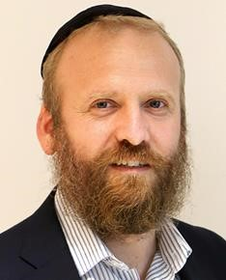**On the music front**, historically, this synagogue followed the musical tradition of Anglo-Jewry’s United Synagogue, with music as compiled for cantor and choir in 1899 in the famous ‘Blue Book’. Currently prayers are led by either Rabbi Eli Levin (left) or members of the community, with an engaging mixture of traditional and modern tunes. Diversity in the community is reflected by the use of Sephardi/Mizrachi musical traditions both in cantillation of Torah and Haftorah, as well as regular melodies, with a dedicated Sephardi/Mizrachi service for the High Holydays. In addition, women’s Megillah readings on Purim, and special Rosh Chodesh services, for instance for batmitzvas, provide a forum for women to participate in Torah services.

A group of 12-15 members get together to form a male voice choir for the High Holydays, conducted by Motti Cohen, a professional arranger and producer who makes appealing contemporary adaptations of classic melodies. Rather than performing to a silent public (halevai/if only!) the role of the South Hampstead Synagogue choir has always been to inspire participation in the community. The choir enjoy this so much that they are hoping to assemble and sing for more services during the year – including this service.

The service on 2 March started at 9.30am. There was a barmitzvah on that day and after the Torah readings the choir sang the Musaf prayers, including ***Etz Chaim, Kedusha and Adon Olam***. A full attendance of 300 plus participated in the electric atmosphere.

On special occasions Motti Cohen joins his professional colleagues in the ‘AhMen A capella Singers’ with Rabbi Levi Levin, younger brother of Rabbi Eli, in a selection of refreshing upbeat liturgical settings. And many community members will recall Yamim Noraim in which Rabbi Eli and his brother Levi add their special ‘kavana’ in duet, in the Rosh Hashana and Yom Kippur Musaf prayers.

~~~~~~~~~~~~~~~~~~~~~~~~~~~~~~~~~~~~~~~~~~~~~~~~~~~~~~~~~~~~~~~~~~~~~~~

**New West End Synagogue, London**

St Petersburgh Place, Bayswater, London W2 4JT website:

## Shabbat 30 March 2024

(The New West End Synagogue and Mosaic Voices with Cantor Marc Joseph also opened the festival with a

**Concert on Sunday 14 January 2024)**

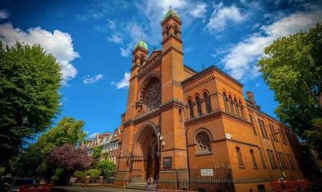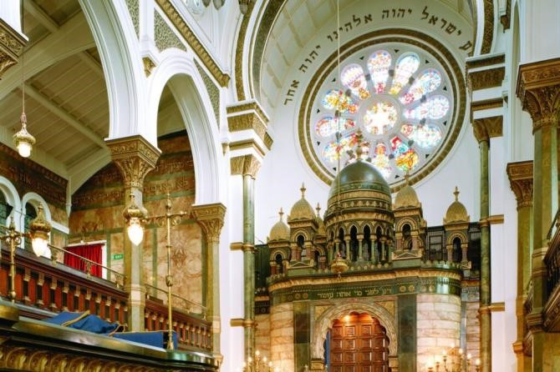

The New West End Synagogue was established in 1879. It has been key to the establishment of Jewish worship since that time. The first Minister was the famous Reverend **Simeon Singer**, who compiled the first daily Prayer Book to be used throughout the English-speaking world. Over time this Authorised Prayer Book became known as, the ‘Singer’ *siddur*, which is basically still in use to this day, many editions later.

The first Director of Music was Mr DM Davis, who compiled the equivalent tome for liturgical music. ‘Voice of Prayer and Praise’ first compiled in 1889 by FL Cohen and Mosely and revised in 1899 by DM Davis and FL Cohen. It was amended – presumably ‘modernised’ by Samuel Alman in 1933 was and is still used throughout the British Empire and Commonwealth, affectionately known as ‘The Blue Book’. This too is the foundation for the Minhag Anglia service melodies.

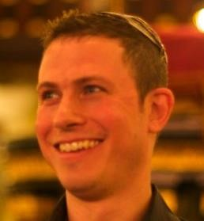The Synagogue today emulates this musical tradition with an active full-time choir ‘Mosaic Voices’, and a musical director Michael Etherton, accompanying services every Sabbath and Festival.

For their ‘From Our Lips …’ Festival service on 30 March, I was most pleased to see an explanatory handout that Michael Etherton the prepared and that was presented to all the attendees. This described so beautifully what prayers they would be singing and who composed them and their significance. This is so helpful – people otherwise might not realise what they are hearing.

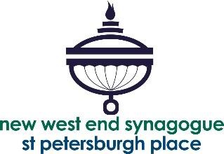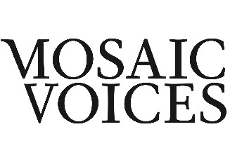**This is what the handout said:**

**Shabbat, 30th March 2024: This morning’s**

**choral service is part of the**

**European Cantors’ Association**

**Festival of Synagogue Music: “From Our Lips”**

One of the most popular musical settings written by American cantor **Sol Zim** (born Sol Zimerman) is of the prayer for the welfare of the State of Israel, ***Avinu sheh’ba’shamayim***. It’s tender, waltz-like, principal melodies have been expertly re-arranged for Mosaic Voices by our **Composer-in-Residence,** **Benjamin Till**. The piece opens with a confident statement of the melody in the alto register. The setting makes full use of the textures of the ensemble, and blossoms into a bright new key towards the end, which gives it an invigorating extra shine.

As the Torah scrolls are returned to the Ark following the Reading of the Torah, Mosaic Voices will sing a setting of ***Eitz Chayim*** (Tree of Life) long associated with New West End Synagogue. The central two melodies, written by **Nissan Blumenthal**, first appear in the Blue Book (The Voice of Prayer and Praise) the key collection of Jewish choral music published in 1899, edited by the then musical director of this synagogue, **David Davis**. These melodies are then wrapped in a third haunting melody written by Benjamin Till, which opens and closes the piece, growing organically from the original, following a long tradition of incremental addition and development of key works in synagogue repertoire. The result is a moving but dignified choral work, which in many ways articulates much that is unique and most indigenous to BritishJewish choral music and to the long choral tradition of New West End Synagogue.

Towards the end of the pandemic, we dedicated a completely new setting of ***Mechalkeil***to celebrate the birthday of a wonderful and much-loved member of our community, Felicity Toube KC. This prayer is sung towards the beginning of the *Amidah* (standing prayer) during the *Musaf* (additional) service. **Benjamin Till** wrote this beautiful new setting with its powerful messages of revival, recovery of the sick, and kindness and mercy, in mind. He also produced a music video of the work, inspired by winter scenes, which you can watch on Mosaic Voices’ YouTube channel. A restful and reflective piece, with its striking, sustained high G towards the end: a musical event, which is most probably unique in synagogue music.

Shortly after the *Mechalkeil,* you will notice the choir move positions to stand together with **Chazan Marc Joseph** on the *bimah* and join him for the recitation of the Kedushah. This is traditionally a ‘call and response’ conversation between chazan and congregation. In this through-sung setting (a practice adopted occasionally for *Musaf Amidah* by most English shuls that have a permanent choir), the choir effectively takes on the role of congregation, but you are welcome to recite your responses as usual during the piece should you wish to. This setting is called the ***Finchley Kedusha****,* simply because that is where it was composed, and it is written by Benjamin Till. It has plenty of great tunes, and ranges wide from sheer exuberance to quiet tenderness, with some catchy solos along the way, which are largely led by the chazan.

Towards the end of *Musaf Amidah*, we will be premiering a setting of ***Sim Shalom***, specially written for us by our talented bass **Luca Weatherall**. It’s always daunting to bring a new piece to life for the first time and composing for synagogue has its unique demands and challenges. Here Luca provides a thoughtful and idiomatic response to the meaning of the words: *‘Make peace, goodness, blessing, graciousness, kindness and compassion upon us and upon all of Your people Israel’*. To conclude the service, by special request, we will be singing an arrangement of ***Adon Olam*** to the tune of the English folk song ***Scarborough Fair***, arranged by Benjamin Till. In this enjoyable setting this wonderful and well-known melody is handed from voice to voice and the music, which is surprisingly demanding to sing, brilliantly makes the best use of the full range of our voices. Shabbat shalom, Michael Etherton, Founder and Musical Director, Mosaic Voices

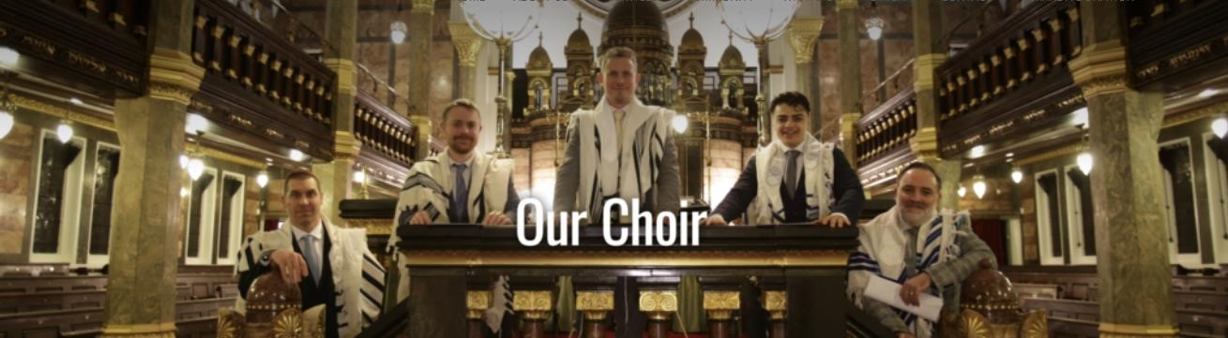

### The Choir – Mosaic Voices

The resident choir of the New West End Synagogue is **Mosaic Voices**, founded in 2012 by its Musical Director, **Michael Etherton**. It is an *a capella* vocal ensemble, of usually four singers, dedicated to performing, recording, filming and commissioning music from the Jewish tradition.

The ensemble, with Michael Etherton at its helm, is very ambitious. Ithad its recording of Kol

Nidrei broadcast on BBC Radio 3’s *In Tune* programme **and** has also been broadcast several times on BBC1, Classic FM and Radio 4.They tackle big subjects. In 2020, Mosaic Voices created nothing less than *The Blue Book,* 177 New Musical Scores of choral arrangements and transcriptions of music from the British-Jewish tradition. They describe the volume as ‘The largest new collection of choral scores created for use in synagogues in Britain since 1933’. Edited by Michael Etherton and Benjamin Till, the 354 musical scores or MP3 learning aids in *The Blue Book,* may be downloaded free of charge from <https://www.mosaicvoices.co.uk/scores-public.html>A full book version will follow soon.

The choir has released four music videos that were written and recorded at various stages of the coronavirus lockdown, within the rules of social distancing. All the pieces were either composed or arranged by their Composer in Residence, **Benjamin Till**. Other composers are also commissioned for performances and recordings, including for example, **Meta Cohen, Luca Weatherall** and **Toby Young.** You can see them on the synagogue website. Music videos include a new setting of Psalm 23; a beautiful Yiddish lullaby, *Rozhinkes mit Mandlen*; *Adon Olam,* sung to the tune of ‘Over the Rainbow’; and a sparky and joyous new *Yism’chu*, recorded and filmed in separate vocal booths at Sonica Studios. See the Mosaic Voices You Tube channel.

Their next project, an album entitled 'Letter to Kamilla' was inspired by a poignant and personal Holocaust related story set to music. The album released by Chandos Records in 2022, received outstanding reviews. It entered the official classical music charts at No. 5 in its first week. Mosaic Voices regularly commissions new music, especially from its Composer-in-Residence, Benjamin Till, and has been broadcast several times on BBC Radio 3, BBC Radio 4 and Classic FM. Live performances include at the Almeida Theatre, London. In January 2024 they premiered a work called **Time**, based on newspaper articles about the New West End Synagogue. Most recently it premiered the film of a major new work by Benjamin Till, **Psalms**, at the Phoenix Cinema in London, which is due to tour across the UK in November 2024. Its next major work is ‘**The Jews of Britain**’, due out in summer 2025.

New West End Synagogue is proud of its long and distinguished choral heritage and their choir’s achievements. More information about Mosaic Voices at [www.mosaicvoices.co.uk](http://www.mosaicvoices.co.uk/)

~~~~~~~~~~~~~~~~~~~~~~~~~~~~~~~~~~~~~~~~~~~~~~~~~~~~~~~~~~~~~~~~~~~~~~~~

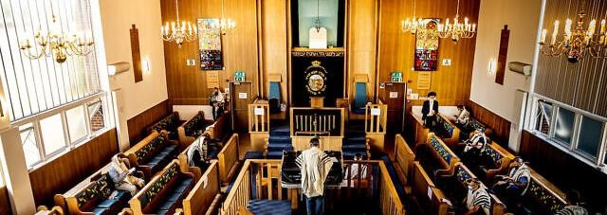

## Mill Hill Synagogue

Station Road, London, NW7 2JU

Shabbat 6 April 2024

**Shabbat at Mill Hill ‘cantored’ off at a cracking pace on 6 April.** Warden Charles Daniels had got all his horses in a row early on, inviting members of the 1800 strong community, set up in 1949, to request what they wanted their guest cantor, Adrian Alexander and choir to sing at Mill Hill’s special ‘From Our Lips’ service, Celebrating Synagogue Music.

There was an air of expectation right from the off, with the community at the edge of their seats to see if their requests had made the cut! All of the 80 men and about ten women present, were keenly listening to what was being presented. This included several people who had walked from Edgware to be present for this musical service. There were at least eight or nine young prebarmitzvah boys and their families in the synagogue.

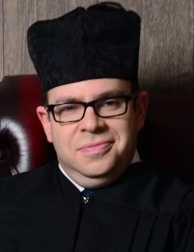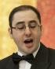There was seamless communication between cantor Adrian Alexander (right) who wore his cantor’s hat and gown, and choirmaster Eliot Alderman (left, and who is also a cantor). They are both local, youngish men, who have worked together frequently at Mill Hill and at Edgware United synagogues, and elsewhere, where they both officiate when invited. The choir of nine stalwart Mill Hill Synagogue members are positioned in the fairly small space

between the wardens’ boxes in front of the *bimah* and the steps up to the Aron Kodesh.

Cantor and choirmaster had excellent eye contact and could respond to each other in an exciting way. Eliot kept the choir under strict control to enhance the harmonies and melodies in a way that encouraged the community to join in and be part of the ruach. Mill Hill’s Community Rabbi, David Rose, in his short address talked about the history, beauty and value of prayer music and welcomed those from the European Cantors Association who were present.

**Nothing dragged**

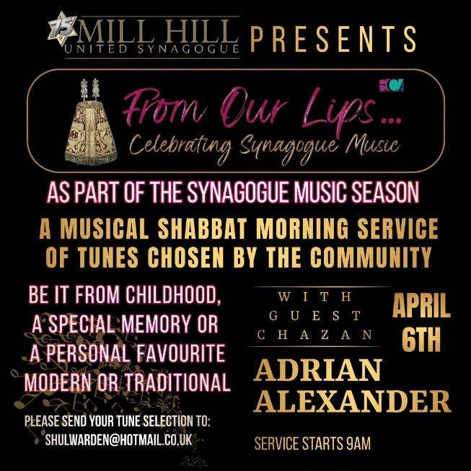It all rollicked on at an exciting speed, even a gallop. Part of the fresh and lively atmosphere may have had something to do with the architecture. The walls on either side are fully glazed from shoulder height right up to the lofty ceiling allowing so much light to flood in and lift the spirit. And the windows open right at the bottom, so that there is plenty of fresh air. Even with all the richness of the cantor and choir’s full-bodied sound of prayer filling the hall and our hearts, the service still ended at 11.49! This service surely stimulated and set everyone up for a good week ahead!

**Warden Charles Daniels was happy with the result.**

Warden Charles was very pleased with the service and said that the response to his reaching out to members had been enthusiastic, and preferences ranged from modern tunes and some Carlebach, to classical *chazanut*. He even had one request for music from Les Mis.

**These were the compositions requested that made the cut:**

*L'eil Baruch* (as taught in Rosh Pina School, composed by then pupil Anna Abrahams, now Anna Wohlgemuth)

*Mimkomecha* - composed by Shlomo Carlebach, with choir (challenging for the cantor)

*Ein Kamocha, Shema, Echad* - Sulzer (traditional) with choir

*Lecha Hashem* - Lewandowski (usually sung in youth services)

*Misheberach* for tzahal - with choir composed by D. Zeltzer

*Rosh Chodesh benching* - composed by Chazanim, Stern and Malovany

*Hovu Ladonai – Mombach*

*Eitz Chayim Hi* to tune of Hatikvah

*Mechalkeil Chayyim* - Bagley

Mussaf Kedusha

*Naaritzcha* and *Kvodo* - tune of Atah banim shiru lamelech

*Mimkomo* - tune of "bring him home" Les Misérables

*Shema Yisrael* - Leib Glanz

*L’dor Vador* - Sol Zim - with Matan Alexander as boy soloist

*Yismechu* - Talmon - with Matan Alexander as boy soloist

*Modim* - as sung by Chazan Mordechai Herschman - with choir, composed by Jacob Rapoport

*Adon Olam* - match of the day!!!

**Cantor Adrian Alexander commented on the Mill Hill Service**:

‘I have never been involved in such a service before. It was a great way for the community to be engaged with the tefilot. The variety of music was wide enough for everyone to connect with at least part of it. When Charles called me up and asked if I would be interested in this project, I was excited but also a little apprehensive as I had no idea what would be requested. However, we ended up with what I believe is a balanced service that is in line with the community. One young gentleman even composed a new *Eitz Chayim Hi* specifically for this Shabbat, but sadly there was not sufficient time to rehearse it, so it will hopefully be sung in the near future, but it demonstrates the level of commitment to shul music at Mill Hill. I was most impressed that the congregation listened intently to some longer more cantorial pieces in absolute silence and concentration. I think the strong message that came through was that this was not the chazan and choir being self-indulgent, rather they were singing the music as requested by the people themselves. This is a subtle but very powerful nuance. The choir members are all volunteers who devote their time and skills to enhancing the shul experience and have attained a high standard under the excellent direction of Eliot Alderman. I hope this project is replicated in other communities with other *chazanim*, to emphasise the importance of shul music and reiterate that it is really the *tzibbur* (the community) that the music is for, not the *chazan* (cantor) or choir.’

The delicious kiddush in their beautiful hall right next door on the same level, was a good opportunity for bonding. Photo above of Mill Hill United synagogue was taken at Chanukah 2020 under Covid restrictions, including social distancing and masks (Credit: Marc Morris)

~~~~~~~~~~~~~~~~~~~~~~~~~~~~~~~~~~~~~~~~~~~~~~~~~~~~~~~~~~~~~~~~~~~~~~~~~

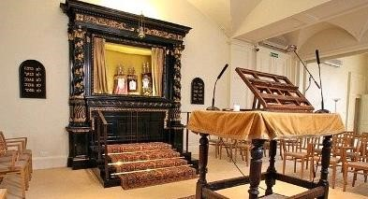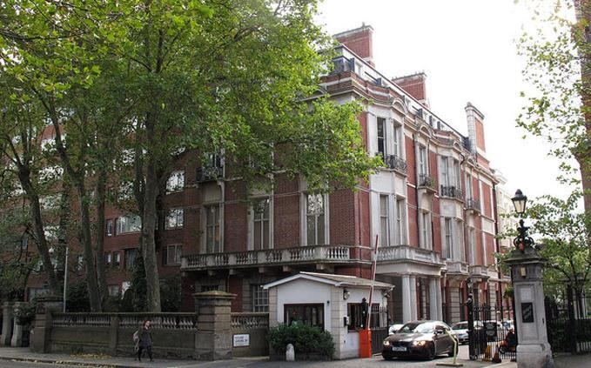

# Westminster Synagogue – London

Shabbat 13 April 2024

Kent House, Rutland Gardens, Knightsbridge, London, SW7 1BX

Westminster Synagogue is a breakaway with Rabbi Reinhart from London’s flagship reform synagogue the West London Synagogue that happened in 1957. Since 1960 it has been based at its beautiful home of Kent House, a five-storey Victorian townhouse, opposite Hyde Park in Knightsbridge, which was once owned by the Dukes of Kent. The calm and elegant sanctuary is a long fairly narrow space. The ‘business’ takes place in the middle, with the organ against the window, the readers desk in the centre and the *Aron Kodesh* on the far wall above the elegant ‘mantlepiece’.

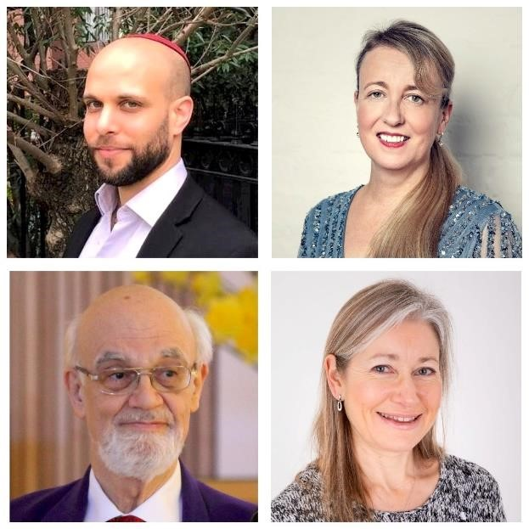For the ‘From Our Lips …’ Shabbat service, which began as usual at 10.30, the congregation, of over 60 people with a range of ages, who are all very engaged in the service, filled all the seats which face the centre. There were two cantorial soloists (usually on a Shabbat only one) Yoav Oved and Sara Feldman Brummer. They stood on either side of the organ which was played for certain pieces by their regular rotating organists Alexander Knapp and Joanna Smith. Sara reported that having both a male and a female soloist seemed to encourage the community to join in lustily. Rabbi Reinhart, had been against having a choir, preferring the community to sing – and they do.

Top photos: Regular Cantorial Soloists: **Yoav Oved** and **Sara Feldmann Brummer**

Bottom photos: Regular Organists: **Alexander Knapp** and **Joanna Smith**

The community was provided with a beautiful leaflet with the history of music in the community and with all the pieces that were sung on 13 April which you can see the content of below.

|  |  |  |
| --- | --- | --- |
| **Westminster Synagogue Shabbat Morning Service – Music List 13th April 2024**  Cantorial Soloists: **Yoav Oved and Sara Feldmann Brummer** Organists: **Alexander Knapp and Joanna Smith** | | |
| **Title** | **Composer** | **Singer** **and** **Organist** |
| Organ music before the service to include: | Shir hama’a lot – Yossele Rosenblatt  Oseh shalom – Nurit Hirsh  Hallelu et Adonai – David Davis  Baruch habah – Samuel Naumbourg  Kol sason v’kol simcha – Traditional Ashkenazi | Alex |
| Mah tovu | Traditional West London Synagogue / Harold Lester | Sara and Yoav Alex |
| Baruch she’amar | *Shabbat* *Shacharit* *nusach* | Rabbi-led |
| Adonai melech / Hallelujah | Charles Salaman | Sara and Yoav Joanna |
| Psalm 23: Adonai Ro’i | Harold Lester | Sara Joanna |
| Psalm 148: Hallelujah | Yoel Sykes (Nava Tehila band) | Yoav Joanna |
| Nishmat | Joseph Sussman | Sara and Yoav Joanna |
| Bar’chu | Louis Lewandowski | Rabbi-led |
| Baruch shem k’vod | Charles Salaman | Yoav Joanna |
| L’ma’an tizk’ru | *Shabbat* *cantillation*  *(Western-Ashkenazi* *Torah* *Trop)* | Rabbi-led |
| Adonai s’fatai tiftach | Unattributed | Sara and Yoav Joanna |
| Kadosh | Traditional Ashkenazi | Sara and Yoav Joanna |
| Yimloch Adonai l’olam | Based (in part) on a melody by Salomon Sulzer | Sara and Yoav Joanna |
| Modim | Cantor Alyssa Pomerantz-Boro | Sara and Yoav Alex |
| Sim shalom | Max Janowski | Sara and Yoav Alex |
| Yih’yu L’ratson | Unattributed | Sara Alex |
| Oseh shalom | Nurit Hirsh | Sara and Yoav Alex |
| Av harachamim | Abraham Dunajewsky | Sara and Yoav Alex |
| Ki mitziyon | Salomon Sulzer | Sara and Yoav Alex |
| Baruch shenatan Torah,  Sh’ma Yisrael, Echad Eloheinu | Louis Lewandowski | Sara and Yoav Alex |
| L’cha Adonai | Edward Hart | Sara and Yoav Alex |
| Eitz chayim | Tanchum Portnoy | Sara and Yoav Alex |
| V’zot haTorah | Edward Hart | Sara and Yoav Alex |
| Havu Ladonai | Israel Mombach | Sara and Yoav Joanna |
| Hashiveinu | Louis Lewandowski | Sara and Yoav Joanna |
| Ein Keloheinu | Zvi Talmon arranged by Raymond Goldstein, rearranged by Stephen Glass | Sara and Yoav Joanna |
| Bayom hahu | Haim Wasserzug | Sara and Yoav Joanna |
| El male rachamim | Traditional nusach | Rabbi |
| Psalm 8  (instrumental version) | Raymond Fischer | Alex |
| Adon olam | Alexander Knapp | Sara and Yoav Alex |
| Organ music at the end of the service | Presto K.15ii - W.A. Mozart | Joanna |

**A short musical history of Westminster Synagogue and its music.**

By Sara Feldmann Brummer, with thanks to Philippa Bernard and Alexander Knapp

**Westminster’s musical tradition** has its roots in the music of West London Synagogue, drawn from the 19th and 20th Century European tradition with notable composers such as Hart, Lewandowski,

Mombach, Salaman, Sulzer and Waley, music from *The Voice of Prayer and Praise* (“The Blue Book”) and pieces by WLS organists Charles Verrinder and Percy Rideout. The repertoire has expanded to include more recent music from Israeli composers such as Nurit Hirsch and contemporary American musicians including Cantor Alisa PomerantzBoro, as well as compositions by Westminster’s former organist and chazan Harold Lester, former organist Raymond Fischer and one of the current organists, Alexander Knapp.

The synagogue’s rotating Cantorial Soloists are Yoav Oved, Sara Feldmann Brummer, Betty Makharinsky, Shira Kravitz and Julieta Kunik.

In her book *The* *History* *of* *Westminster* *Synagogue* (2003) founder member Philippa Bernard describes the community’s musical beginnings. ‘Provision of music for the services was not easy. However, a piano was available and Mrs Lily Ball accompanied a voluntary choir.’ Rabbi Reinhart reported, ‘We attempt congregational singing - we are attempting the impossible – we are hopeful of success’.

A young Israeli pianist, Gideon Shamir, helped out with the music. Rabbi Reinhart wrote at that time to another young musician, inviting him to provide music for the services, but the recipient of the letter left it on his mantlepiece for nearly a year. Then he re-read it and telephoned Harold Reinhart apologising for his neglect. ‘Do you still need a pianist for your services?’ he asked. ‘We do indeed’, was the reply and thus Harold Lester joined the congregation which he has served so generously for some forty-five years as organist, accompanist, chazan, Purim entertainer and in many other ways.” In 1972, an organ was installed at Kent House, ready for the High Holy Days. This was then replaced in the early 2000s with the organ that is used currently.

Following Harold Lester, Raymond Fischer took up the post of organist, a role he held for many years. He was joined by Alexander Knapp in the early 2000s, when a rota system was started. Joanna Smith joined the organist rota in 2004. Raymond Fischer passed away in December 2023.

Currently the synagogue has a rota of solo Cantorial Singers for Shabbat morning, accompanied by an organist. On the last Shabbat morning of every month the soloist sings unaccompanied; recently there have been two unaccompanied singers for some of these services. For High Holy Days there are two Cantorial Singers (one man, one woman) who sing together accompanied by organ, taking turns to sing solos, singing harmonised duets and singing together in unison.

The current Cantorial Soloists are Yoav Oved (since 2017), Sara Feldmann Brummer (since 2019), Betty Makharinsky (since 2019). Shira Kravitz and Julieta Kunik joined the rota in 2023. Organists are Alexander Knapp and Joanna Smith.

Friday evening services feature more contemporary Israeli folk music and recent American Jewish compositions, sung *a capella*. Yoav Oved often sings, and occasionally the singer leading is Emily Moxon or Julieta Kunik. For High Holy Days Family Services, the musicians are Joanna Smith and Suzanne Goldstein. Over the years, previous singers have included Esther Salaman Hamburger, Marta Shelley, Sue Shepping, Harold Lester (organist and singer) Judith Silver, Vivienne Trenner and Mark Glanville.

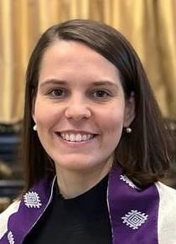**Rabbi Kamila** has an impressive record of achievements. She speaks four languages, Czech – her mother tongue – English, Hebrew and German. She earned her PhD in Jewish Theology at Charles University, Prague, and went on to study at Abraham Geiger Kolleg in Potsdam, and the Conservative Yeshiva in Jerusalem. (Westminster Synagogue’s Senior – though still very young. Rabbi Benji Stanley was on leave.) In thanking the officiants who had planned so meticulously Rabbi Kamila said: *Thank you all for such a fantastic service.* ***It was so powerful - for me*** *personally one of the best services yet, I had goosebumps at least 3 times. It would not be possible without all the planning, rehearsing and organising - thank you all for putting in all the time and love you did.*

**Sara Feldman Brummer** Cantorial Soloist who had been instrumental in planning the delivering the service said:

*I think, at both of the synagogues where I sing that* ***the ‘From our Lips’ project helped to start a deeper conversation about the music that we sing in our services, within the community and within the music and rabbinical team.***

*At Westminster, it reminded me of how the musical connections we have there, some dating back to the synagogue's origins at West London Synagogue (where I am a member myself and sang with the choir for 18 years) others connected to musicians that have played at Westminster in previous years. This was why we wanted to include some of their music.*

~~~~~~~~~~~~~~~~~~~~~~~~~~~~~~~~~~~~~~~~~~~~~~~~~~~~~~~~~~~~~~~~~~~~~~~~~~

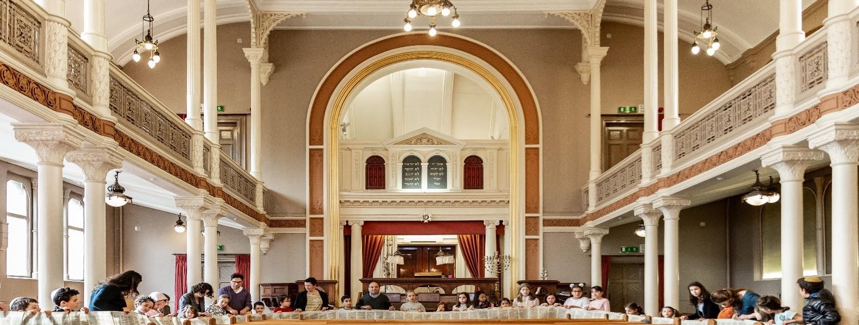

# New London Synagogue

33 Abbey Road, London, NW8 0AT

## Shabbat 13 April 2024

**New London Synagogue** a Masorti synagogue and congregation in St John's Wood, is another instance of a Rabbi breaking way from an established synagogue, with his flock. This followed the widely publicised ‘Louis Jacobs Affair’ in **1964**,in which **Rabbi Louis Jacobs** who had been the popular and admired rabbi of the New West End Synagogue, widely expected to become the next Chief Rabbi, was after the publication of his book ‘We Have Reason to Believe’ removed from his teaching post at Jews’ College and refused a ‘certificate of competency’ to return to his former, now vacant, position at the New West End.

At this point 500 of his devoted followers followed him out of the United Synagogue and together they created a brand-new congregation. The building at **33 Abbey Road** had been the home of the St John's Wood United Synagogue. However, that congregation had built themselves a spacious new synagogue round the corner in Grove End Road and this building was being sold off for demolition. Louis Jacobs’ supporters secretly set up a shell company and purchased it from the United Synagogue without disclosing they intended to establish a congregation with Louis Jacobs as its rabbi. This congregation, the New London Synagogue, was led with distinction by Rabbi Louis Jacobs for over 40 years, during which time it has become the ‘parent’ synagogue of the Masorti movement in the United Kingdom, which now numbers several congregations.In 2008 Rabbi Jeremy Gordon returned to the Synagogue in which he grew up, now as Rabbi.

New London follows the traditional orthodox synagogue service. Prayers are almost exclusively in Hebrew and they meticulously use the correct *Nusach*, or modes. They use the Koren Sacks *siddur*, the first new Orthodox Hebrew/English *siddur* (prayer book), published in cooperation with the Orthodox Union, in 2006. The *siddur* exemplifies the publisher, Koren’s traditions of textual accuracy and intuitive graphic design, and offers an illuminating translation, introduction and commentary by one of the world’s leading Jewish thinkers, Rabbi Jonathan Sacks. They use the Koren Sachs *Machzor* (holiday prayer book) and both the Hertz and Etz Chayim *Chumashim* (Biblical texts). Men and women sit together during services, and since 2005 also play equal parts in leading them.

Rabbi Jeremy said: ‘I'm so delighted that New London Synagogue has joined the merry band of communities supporting, and gaining support from, the From Our Lips celebration of synagogue music. The music of prayer is such a vital part of my own connection to Judaism, and this celebration – drawing together such a diverse collection of cantors, choirs and lovers of music – is a wonderful way to wave a banner – in Hebrew a Nes, miracle – for this wonderful art.

‘Our wonderful musical tradition was formed by our founder chazan, George Rothschild who led this community in two stints with distinction for almost 35 years until his retirement in 1999. New London synagogue inherited the mixed choir from Hampstead Synagogue that had been started by the famous Samuel Alman (who had revised the Blue Book in 1933) and was the last London

United Synagogue to be permitted to have a mixed men and women’s choir. Conducted by Willy Scharf they enhanced services for many years. Chazan Stanley Brickman served briefly in the 1960s. Chazan Stephen Cotsen took over in 1999 and Cantor Jason Green served for four years from 2014, before Chazan Cotsen returned to New London in 2018.

‘At New London we like to sing. We blend the traditional choral classics by Lewandowski, Sulzer,

Alman and Naumbourg with more modern compositions by **Shlomo Carlebach, Meir**

**Finkelstein**, **Debbie Friedman** and others as well as compositions created by our member, the composer **Julian Dawes**, and our previous chazan, **Stephen Cotsen**.

‘As well as our current cantorial leadership of **David Djemal** and **Yoav Oved**, we have a growing number of members who regularly lead services, read from the *Torah* and chant the *Haftarah.* It is an important part of our ethos to encourage much greater participation in and leadership of services by our members – especially our younger members following their *bar- or batmitzvah*. There are often courses and other opportunities to develop skills. Anyone keen to participate in services is encouraged to contact chazan@newlondon.org.uk.

‘Thank you, and all the ECA team for the opportunity to be part of this. for Shabbat on 13 April, we have invited as our guest cantor, Moshe Dubiner, London’s most senior cantor who has officiated in various synagogues for over 70 years.’

**Moshe Dubiner**

Cantor Moshe Dubiner was born in London and brought up in a Chasidic atmosphere, attending the Yesodey Hatorah School, followed by Schneiders and Eitz ChaimYeshivot. At only 16 years old he was accepted as a student at Jews College where he studied chazanut with Rev Leo Bryll. He studied voice production under Dino Borgioli and the eminent Harold Miller. At the age of 17 he officiated at the Great Synagogue in Commercial Road in the East End and later at the Great Garden Street Synagogue where he was cantor for 2 years. In 1962 he was appointed cantor at Bayswater Synagogue, following in the footsteps of Rev Leo Bryll himself, and two years later accepted the post of cantor at Brondesbury Synagogue, taking over from Rev Aaron Elfand. When Rev Faigenblum retired from Cricklewood Synagogue, Cantor Dubiner took over and served them for several years. In 1980 held the post of cantor when the Western Synagogue amalgamated with Marble Arch Synagogue. For the last 70 years Cantor Dubiner has combined running a successful silverware business with being a part-time cantor in various communities, ranging from Bournemouth via South of France to Israel and the USA.

**~~~~~~~~~~~~~~~~~~~~~~~~~~~~~~~~~~~~~~~~~~~~~~~~~~~~~~~~~~~~~~~~~~~~~~~~~**

**Chabad Lubavitch of West Hampstead**

35-37 Fairfax Road, London, NW6 4EW

Rabbi Menachem Vogel

Cantor Moshe Dubiner encouraged Chabad of /West Hampstead to participate in ‘From Our Lips …’ Celebrating Synagogue Music Festival and offered to be the guest chazan

**Chabad of** **West Hampstead** was established in 2010 with **Rabbi Dovid & Chana Katz.** Rabbi Vogel who officiated on the day is the assistant and youth Rabbi. Chabad of NW6 is dedicated to serve every Jew with Ahavat Yisrael and unconditional love. Their broad spectrum of programs strive to ensure Jewish continuity and identity through increasing Jewish education, pride, knowledge, practice and commitment. The Chabad Jewish Centre provides a ‘Home away from Home’ for all Jews in a warm and friendly environment.

Current membership is about 300. 60 to 80 usually attend on Shabbat from 10.00am – 12.30. They use the Nusach Arizal – Chabad *siddur*. They don’t usually have a cantor or a choir. The rabbi, gabbai or cantor choose the tunes which are usually traditional Chabad tunes. Guest cantor Moshe Dubiner chose his own tunes.

### ~~~~~~~~~~~~~~~~~~~~~~~~~~~~~~~~~~~~~~~~~~~~~~~~~~~~~~~~~~~~~~~~